**Feasibility Study Date: 03/09/2019**

**Food ordering and Payment App for PES**

**TEAM NAME : Team 5**

**SECTION : C**

**Team Members :**

1. 01FB16ECS124 - Gundam Satyabhama Reddy
2. 01FB16ECS143 - Ishita Bhandari
3. 01FB16ECS131 - Harshith Arun Kumar
4. 01FB16ECS128 - Hari Charan U
5. 01FB16ECS141 - Iresh Shankarayya Hiremath
6. 01FB16ECS172 - Kunal Paliwal
7. 01FB16ECS139 - Hrishikesh S
8. 01FB16ECS166 - Kevin Paul Kodiyan
9. 01FB17ECS713 - Harshith H.K.
10. 01FB16ECS173 - Kusumanjali R

**Revision History**

|  |  |  |  |  |  |
| --- | --- | --- | --- | --- | --- |
| **Revision #** | **Date** | **Author** | **Where** | **Change** | **Approved by** |
| 1. | 29-08-2019 | Hrishikesh | Systems Objectives | Changes in Block Diagram | Satyabhama |
| 2. | 31-08-2019 | Kunal | Schedule | Schedule changed | Ishita |
| 3. | 05-09-2019 | Kusumanjali | Product Marketplace | Made changes in MarketPlace | Harshith |

Table of Contents

1. Problem Statement

2.Executive Summary

3. Current Systems and Processes

3.1 Current Operations

3.2 Physical Environment

3.3 User Organization

4. Systems Objectives

4.1 Description of Products and Services

4.2 High level Block diagram showing the solution

4.3 Targeted Customers and Benefits

4.4 Technology Considerations

5. Product/Service Marketplace

6. Marketing Strategy

7. Organization and Staffing

8. Schedule

9. Financial Projections

10. Assumptions and Constraints

11. Issues

12. Alternatives

13. Findings and Recommendations

13.1 Project objectives

# **PROBLEM STATEMENT**

An app where students can order food from cafeteria/caterers beforehand to avoid congestion during break times. The app also allows students to make other payments within PES. The Vendors will be able to share the menu for the day. We are hoping to add a “Swiggy for home food” delivery feature, wherein food items can be ordered from regular homes, thus helping people have the home food they crave.

A vendor view and a customer view would be created, and sufficient payment options would be provided.

# **Executive Summary**

According to analytics, 3.5 million orders are placed on Zomato every month, with a further 4.5 million orders per month on Swiggy. This has led to an unprecedented use of applications for ordering food items. Waiting times are also considerably reduced.

In our project, we hope to create a food ordering and payment app for PES University, that reduces waiting time (Common issue at cafeterias) so that orders can be ready when someone goes for picking it up. We also propose a delivery system for home food, that would help people beat the monotonicity and unhealthiness of restaurant food. A vendor view would help vendors put up the food items that are available, and is seamlessly integrated with our payment system that helps transactions occur smoothly. Current operations includes searching of restaurants, ordering food, facilitating various online payment methods and tracking of order. Block diagrams of the working of the various modules of the app have been presented below, and the economic factors favor us pursuing this app, in the sense that there is an opportunity to capture some of the market, with reference to students making use of this extensively. Environmental, Social, Legal and Technological factors have been discussed, and steps to deal with them have also been presented.Various stages of the development of this app have been presented - Analytics, online payment, vendor menu display, online order & Delivery, Comment and Ratings, Automatic token generation and the Final app launch. Deadlines for this have been tabulated, and we intend to complete work according to this timeline. Our financial projections indicate a growth factor that supports our decision to pursue this project. Recommendations would be taken all along the way, and our expectations would be hoped to be met, creating an app that reaches our goals.

# **Current Systems and Processes**

There are quite a few already existing systems are there through which you can place your order and payments can be made online.

Process of ordering food deals with an instant search of restaurants, streamlined flow of food items, then placing order for the desired food items followed by making payment and then finally delivery agents collect it and delivers.

Above mentioned ones are working in general way. Which are not helpful for large institutions and companies where they have their own cafeterias and canteens and stalls , where the students, staff and employees need to wait in queues to place orders for food and again wait until the food gets prepared. This process consumes lots of time and energy.

Furthermore, there usually does not exist a system which provides an overall comparison of all the cafeterias and canteens in terms of the menu and prices. This will aid the customer to have a better understanding of all his options and help her to choose better, again saving a lot of time and energy as compared to personally visiting every cafeteria and getting information.

**3.1 Current Operations**

Current operations includes searching of restaurants, ordering food, facilitating various online payment methods and tracking of order.

Now we implement the same ideology and make it specific for a single institutional/organizational body by allowing the people to pre-order their food using their smartphones and avoiding standing in queues and staying there until food gets prepared.

Therefore this system has the operations such as choosing cafeteria or stalls, selecting items that are available, placing orders, billing, online payment, getting digitized tokens tokens, catalogue of menus, then collecting your items just by showing your token so that we can avoid congestion in front of stalls.

**3.2 Physical Environment**

The current physical environment of cafeterias in universities and organizations do not include any kind of hardware or software support for food ordering and tracking, resulting in customers waiting in long queues for variable amount of time. Moreover, there is no existing system to order food from nearby tiffin services. We aim to solve these problems via creating an application where the customer can choose items from the integrated menu of all the cafeterias and tiffin services and place & track their orders easily.

**3.3 User Organization**

There is no focus on any particular group of people, anyone can use this platform within the specified geography .

# **System Objectives**

Canteens and cafes in universities have become extremely crowded and serving the food on time has become extremely difficult for vendors, because of which the customer has to stand in long queues and wait for their orders.

**4.1 Description of Products and Services**

We aim to solve the above mentioned problems by our product which includes the following services:

1. An online platform solves these issues by helping the vendors to accept payments and token generation for food ordered in a more sophisticated, fair manner and students wouldn’t have to wait in queues for too long.
2. By taking part in this online platform, canteens and cafes can conduct their business efficiently and also advertise their chains in the process. While creating/improving the online presence, food catering chains can also get contract opportunities in other institutions and places of work, thus increasing revenues and creating a large customer base.
3. Analytics provided by the platform will help vendors in planning and designing their menu and budget.
4. The platform can also provide a service where food can be delivered from home, enabling home-makers to deliver fresh food and allowing private individuals to earn an income. This feature also includes real-time tracking of the order to aid customer experience.

**4.2 High level Block diagram showing the solution**

High level block diagram for canteens

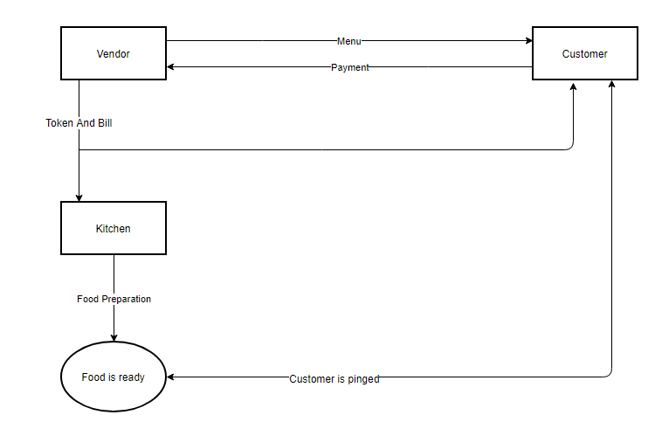

Food Delivery

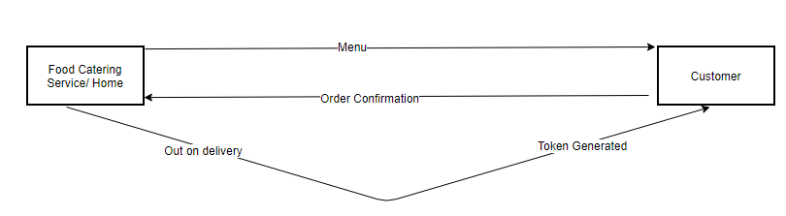

Food Testing

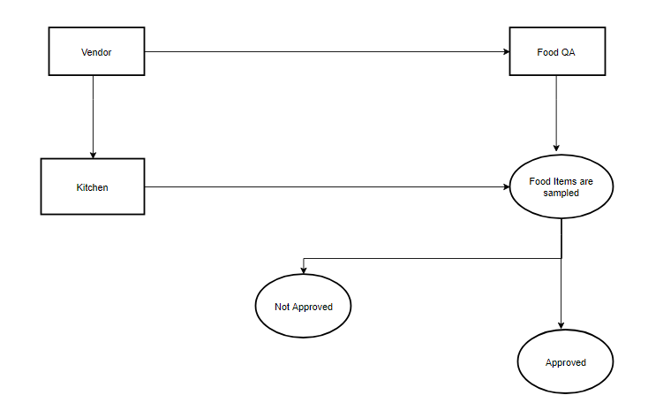

**4.3 Targeted Customers and Benefits**

Food catering services, canteens and cafes are going to benefit from this system automation, making business easier. The visibility of their business will improve as potential clients can also view them on the platform.

Customers can order food online, making transactions easier and they don’t have to wait in lines. Another potential customer will be educational institutions and corporates who would like to hire a particular food catering service due to their presence on their platform. Customers who would like to get their food from home/any catering service, can get it delivered hot and fast.

**4.4 Technology Considerations**

The platform will be available as a web application and will also have an/a iOS/Android application. The canteen/cafe should have good internet connection to have a low-latent token generation. The online transactions must be conducted in a secure manner and every payment done, should go to the vendor immediately. A database will be available to look into a history of transactions to prevent any issues of non payment. Each vendor has to update the menu when required. Additionally, new online marketing functionality must be considered in order to target existing and potential vendors and customers through methods such as e-mailing lists, promotional advertisements, and loyalty discounts. The vendors do not need any special type of technological requirement like servers as every processing and maintenance of the web application will be done by the developers themselves.

Regarding food delivery aspect, the food catering services are also expected to join our platform from where customers can order food from catering services and home-makers, something similar to a ‘dabba-walla’ service.

# **Product/Service Marketplace**

Market Attractiveness: PESTLE ANALYSIS

**How Political Factors Affect Our Project:**

* Creation of the New Age Incubation Network (NAIN) by the Government of Karnataka: Grants and supports will be given to start-ups. Start-up India Action Plan by the Indian government.
* Political Stability in the country for the next 5 years, would ensure no current policies would change half way through.

**How Economical Factors Affect Our Project:**

* Industry growth rate is growing exponentially.
* Inflation rates are in lower range: The inflation rates fell till 1.97% in Jan 2019 and presently stands at 2.92%.
* Total GDP: in Bangalore City will be above the National average over 2016-20
* Positive future growth for this Industry: Sources estimate India to grow 7.5% in FY 2019-20.

**How Social Factors Affect Our Project:**

* 59% of the population of Bangalore, 65% of that of Karnataka and 242 million people of India are in the age range of 20-45 years, our target market.
* The number of households with bachelors/spinsters, 2 working parents and nuclear families is steadily increasing while The number of people who cook and eat at home is also decreasing, which means our target market is steadily increasing too.

**How Technological Factors Affect Our Project:**

* Technological impacts on the industry is very high, since the customer interacts with us via our online platform.
* Automation:The entire process, right from placing an order to being delivered to the customers while for the vendors: taking the order and delivering it is fully automated, which makes the process hassle free and easy to use for all of them involved.
* different user interface for vendors and customers lightens their burden and makes business transactions easier.
* Broader reach due to use of the Internet.

**How Legal Factors Affect Our Project:**

* Violations of deals will lead to several legal repercussions to the deal-breaker. Hence the industry has a certain protection from fraud and other potential threats.
* Guidelines and frameworks set up by the government will prevent players from making profits using substandard or illegal products and hence undermine the entire industry.

**How Environmental Factors Affect Our Project:**

* The use of plastics has been heavily regulated by government bodies, with the Government of Karnataka banning all single use plastics. Since both our vendors and customers are in the same University as of now, we will not use any plastic covers to deliver, just the container will be given to the customer.
* Other delivery apps like Swiggy’s delivery agents travel with their bikes to deliver while our customers are just walking to the shops inside the campus reducing the carbon footprint.

**GEOGRAPHIC SEGMENTATION:** Our project will be first unveiled and operated in PES University and gradually rolled out to other Universities and Workplaces(Selective Distribution).

**DEMOGRAPHIC SEGMENTATION**: The target age-group for our project is 18-35 years.The Target Audience are Students Bachelors/Spinsters, households with 2 working parents and people who don’t cook food at home

**BEHAVIOURAL SEGMENTATION:**

* Benefits such as quality and nutrition will be assured by having food inspection personnel to check the parameters of food quality.
* On time delivery will play a crucial role in the growth and sustenance of the start-up.
* Generally during break hours, because of the chaos caused by the rush and the customers impatience leads to them losing out on some change(<Rs10).Although it looks like a small amount when you add it up, the sum is quite a lot for a student to lose out on. This loss is emitted out of the entire process as they can pay through online payment systems such as Paytm, GooglePay, etc.

# Marketing Strategy:

*How does an organization differentiate itself from its competitors; types of marketing the organization will utilize who the organization will target(Segmentation).*

*.***Positioning:**

Unique Selling Proposition – Key Differentiation: Hassle Free Ordering of food.

**Promotion:** Word of mouth, Posters inside the campus & forward it on Whatsapp groups.

Forwarding posters on whatsapp is the most simple and efficient way to reach out to students and hence we haven’t used Digital Marketing Strategies.

But with respect to other institutions, then Marketing strategies such as Social Media Ad’s, Email Marketing, Coupons, etc will be established to not only attract new customers but also sustain them.

Place: Institutions like PES University

Price: as shown on the menu.

Product: The app lets the customers place orders (food, stationary) so the stalls can be informed prior and their order is ready to be picked up. This ensures the alot of food is not wasted from the vendors side as they already get an estimate of orders and the customers don’t have to go and wait in queues and lose out on the break.It also ensures a hassle free transaction for both parties.

**Differentiation:**

* Our competition is food delivery apps like swiggy and their cloud kitchens like homely and the bowl company. But while they charge a minimum of Rs 25-50, we on the other hand will be cutting the delivery fees.
* Because we are tying up with Institution(such as PES) caterers, our delivery will happen much faster than any other food delivery apps as it is all with one campus itself.
* We will also list the Campus mart where people can purchase stationery items too.This will avoid chaos at the campus mart and lead to hassle free transactions without the students having to lose out on break times standing in lines.
* By providing a more convenient means of purchasing our products online it is expected that we will retain these customers with just word of mouth and Posters around the campus, WhatsApp campaign for new customers as well.

# **Organization and Staffing**

Staffing Position #1:   
Sales Analyst – This role position will be a service option available to vendors, to help improve analysis of sales, to project income / expense for the coming quarter

Staffing Position #2:  
 Platform Service engineer – Responsible to maintain the servers, and handle

Staffing Position #3:  
 Marketing Head:-   
 PoC for vendors, to integrate additional features, and improve outreach for customer acquisition.

# **Schedule**

The following is a high level schedule of some significant milestones for this project:

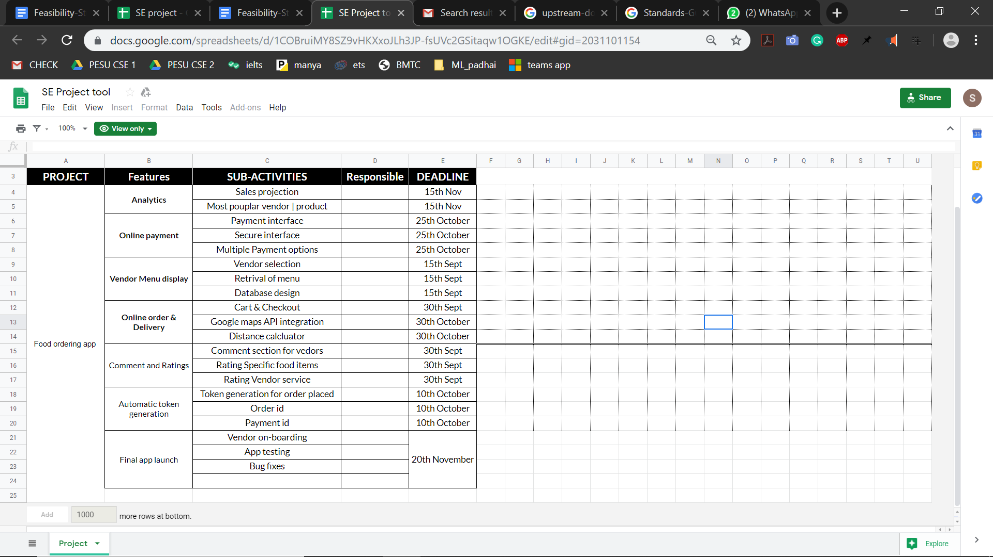

# **Financial Projections**

All figures below are in rupees. We propose a minimum year on year growth of 30% in revenue.

|  |  |  |  |
| --- | --- | --- | --- |
| **Balance Sheet Years 1-3** |  |  |  |
|  |  |  |  |
| **Prepared By: Harshith Arun Kumar** | **Company Name:** | Food Ordering And Payment App for PES |  |
| Owner: SE TEAM - C5 |  |  |  |
|  |  |  |  |
| **ASSETS** | **First Year(** | **Second Year** | **Third Year** |
| Current Assets |  |  |  |
| Cash | 10,000 -(Say) | 30,000- | 90,000- |
| Accounts Receivable | - | 10,000- | 20,000- |
| Inventory | 30,000- | 50,000- | 1,00,000 |
| Prepaid Expenses | 10,000- | 30,000 | 90,0000 |
| Other Initial Costs | - | 20,000- | 30,000- |
| **Total Current Assets** | **Rs-50,000** | **Rs-1,40,000** | **Rs-3,30,000** |
|  |  |  |  |
| Fixed Assets |  |  |  |
| Real Estate -- Land | - | - | - |
| Real Estate -- Buildings | 10,00,000- | 20,00,000- | 25,00,000- |
| Leasehold Improvements | - | 2,00,000- | 5,00,000- |
| Equipment | 5,00,000- | 10,00,000 | 15,00,000 |
| Furniture and Fixtures | - | - | - |
| Vehicles | - | - | - |
| Other | - | - | - |
| **Total Fixed Assets** | **Rs-15,00,000** | **Rs-32,00,000** | **Rs-45,00,000** |
| (Less Accumulated Depreciation) | Rs-1,00,000 | Rs-1,50,000 | Rs-2,00,000 |
| **Total Assets** | Rs-14,00,000 | Rs-30,50,000 | Rs-43,00,000 |
|  |  |  |  |
| **LIABILITIES & EQUITY** |  |  |  |
| Liabilities |  |  |  |
| Accounts Payable | - | - | - |
| Commercial Loan Balance | - | - | - |
| Commercial Mortgage Balance | 14,00,000- | 25,00,000- | 33,00,000- |
| Credit Card Debt Balance | - | - | - |
| Vehicle Loans Balance | - | - | - |
| Other Bank Debt Balance | - | - | - |
| Line of Credit Balance | 2,00,000- | 4,00,000- | 4,00,000- |
| **Total Liabilities** | **Rs-12,00,000** | **Rs-21,00,000** | **Rs-29,00,000** |
| Equity |  |  |  |
| Common Stock | 20,000 units- | 40,000 units- | 1,00,000 units- |
| Retained Earnings | - | - | - |
| Dividends Dispersed/Owners Draw | - | - | - |
| **Total Equity** | **Rs-NA** | **Rs-NA** | **Rs-NA** |
|  | No IPO yet |  |  |
| **Balance sheet in or out of balance?** | Rs- | Rs- | Rs- |
| Balanced! | Balanced! | Balanced! |

# **Issues**

* What architectural style is the application going to be built with? ( Microservices architecture, Client-Server architecture, REST style, etc.)
* Is the application going to be web based or is it going to be individually coded in native android , iOS and Windows languages?
* Should we use off-the-shelf technologies or code everything from scratch? ( Coding everything from scratch ensures bit - level security.)
* What additional hardware and software do the parties in participation need to install?
* How does the application store user data?
  + Does the application use a database or not?
    - If it does have a database, is it relational or non relational?
    - If it does not , we store it in files, what data format do we use ? ( json, CSV, etc.)
* What programming languages is the application going to be built on?
* Security - How does the application ensure Confidentiality, Integrity and availability of user information ?
  + Confidentiality- What security measures will the application possess to prevent unauthorized access to information.
  + Integrity - How does the application verify that the information is not being tampered.
  + Availability - Downtime results in loss of revenue. How do we ensure high availability of the application?

# **Assumptions and Constraints**

Constraints-

* Time constraint - 600 hours
* Constraint on the number of people working on the software - 10

Assumptions -

* The time constraint does not allow the development of all the code from scratch. So, we resort to the use of off-the-shelf technologies under the assumption that they are secure and trustworthy.
* We assume the existence of all the equipment required by all the involved parties. ( i.e customers need smartphones to order, vendors and delivery agencies need a computer, a high speed data connection and staff to man the computer.
* We assume the completion of development of the software under the specified time and resource constraints.

# **Alternatives**

Alternatives suggests the various available possibilities for the expected outcome of the system.

As of the beginning phase, Implementation of the front end is to be done via 2 availabilities i.e, via a Web page on the browser and the latter being a native stand alone application both on Android and IOS device platform.

Web page on the dev. End is easier and quick to implement to get it up and running and does not exactly cost much in making and the main benefit being the cost effective and less time consuming on UI end but lacks in providing the user friendliness that is provided on the mobile application but at the same time isn’t reliable and security of payment via Cards is a again an issue via a web page as to OTP verification is to be carried in different portal and totally depends on the server it is to be hosted on.

On the other hand a Mobile App will have a way better user friendly behavior and makes it easy to use for the user as it is just one click away from the pocket as to browsing a browser and surfing the net but at the same time has its own Demerits main being the time consuming in building the application for both platforms and maintenance is a challenge and at the same time very expensive in terms of time and money.

Dedicated servers - Another key alternative being dedicated servers

Servers play a very important role in hosting a particular web application or a mobile application.

Servers role in storing website or application on the cloud and decides as to how fast a particular web page responds to a request, having a single dedicated data center for the servers to the system is very expensive and for a small scale application like ours it is seemingly not a good choice all though it can be achieved and will provide rich resource and less failures and 24 hours up and running servers but again maintenance and man power and resources are beyond the reach.

So a better alternative would be running the system on an outsourced servers like Amazon EC2 or firebase which are as efficient as having a dedicated servers but worry less when it comes to server being down or issues with data center or maintenance perspective but the only demerit being the buying these premium package do cost and are expensive but are affordable when compared to having a data center and maintaining it.

# **Findings and Recommendations**

Although there exists quite a few food ordering applications and platforms of various kinds, our application, essentially, hopes to localize the process of purchasing food at an institution with a similar ideology behind these food ordering applications in an effort to make this process seamless and effortless. Apart from this objective, we also hope to promote the notion of eating healthy(especially for those whose lifestyle makes it difficult to have healthy food) by extending the platform for home cooked meals to be delivered to interested parties.

Below are a few pros and cons of the proposed platform:

Pros:

* Seamless process of purchasing food at institutions and organisations like colleges, companies, etc.
* Analytics on both ends of the platform helps create a win-win situation for vendors and consumers alike.
* Promotes the eating of healthy food.

Cons:

Based on the research shown above, the social and economic impacts of the proposed platform drives the recommendation that this application’s implementation be initiated.

**PROJECT PLAN**

1. **Deliverables of the Project**

* An app to order and pay for food both from canteens and caterers.
* App allows users to rate and review food/vendors.

1. **Process Model which you intend to follow**

We plan on using Waterfall Model because of the following reasons :

* Simple, easy to understand and use.
* This approach has control over deadline as work is distributed in the team in each stage.
* All phases are clearly documented and understood well in the beginning of software development life cycle.

1. **Identification of the upstream-downstream partners needed for the product**

* Vendors
* Banking Service providers
* Caterers

1. **Resources needed for the project/product**

* Computers in the canteens for the vendors to see the orders.
* Servers to maintain the app and database.

1. **How are you organizing your team in the project**
2. We have assigned a team leader who distributes the tasks evenly among the team members.
3. We also assign deadlines for each individual which enables us to plan reviews and testing for them accordingly.
4. The other team members then review each other's work and provide with suggestions and corrections.
5. **Standards-Guidelines-Procedures** 
   1. **Standards:**
   * All the transactions via card/UPI should be encrypted.
   * User details should be securely saved on the servers.
   * App login should be password protected.
   * The validation token should be unique and encrypted.
   1. **Guidelines:**
   * Application should be made resilient using a load balancing logic to withstand server failures.
   * High end encryption techniques should be used like Sha256 for stationary and nonstationary data.
   1. **Procedures:**
   * Create a theoretical model for the application
   * Create a list of requirements.
   * Create a detailed plan for each requirement.
   * Develop and test each requirement separately.
   * Combine all the modules together.
   * Write unit tests and finish the testing procedure.
6. **Communication Mechanism**

Using mail for communication is hard to keep track of. Therefore we created a slack channel to communicate within the team. We also created a github repository to share the project folder and to simultaneously work on it. Any project related documents to be shared will be done through the google group “se-2019-c5”.

1. **Risks**
   1. **Project related risks:**

* Limited resources leading to multiple app crashes
* Unchecked cases leading to catastrophic app failures or errors thus customer dissatisfaction.
  1. **Non-Project related risks:**
* Internet issues while payment may cause transactional errors.
* Poor communication with the delivery personnel can cause cancelled deliveries.

1. **Quality Criteria**

The following criteria can be considered to measure the quality of the app

* The app should reduce the congestion at canteens
* The app should be user friendly and intuitive
* It has to be secure
* It should be scalable and available even when there is heavy traffic

1. **Work Packages**

* Pre-order food at canteens
* Payment gateway for money transfer
* Order food from caterers and home-food makers
* Food reviews

1. **Budget and Schedule**

* Front End Design - Satyabhama
* Database creation and management - Kusumanjali
* Secure payment API - Harshith Arun Kumar
* Reviews and comments - Harshith H K
* Ordering food and token generation - Ishita
* Ordering food from catering services - Kevin P
* Food Testing - Hrishikesh
* Testing - Kunal
* Integration - Hari Charan
* Sales Projections - Iresh

1. **Delivery means**

We plan on delivering the product as a Hybrid Application which can be used on both iOS and android.